**Creating a New Ruby on Rails Project Inside a Docker Container**

**Docker Commands Recap:**

docker ps

– List running containers.

docker stop <container_id_or_name>

– Stop the container.

docker restart <container_id_or_name>

– Restart the container.

docker exec -it <container_id_or_name> /bin/sh

– Re-enter the container workspace.

**Step 1: Ensure Docker container is running**

Ensure your Docker container is running. If not, start it using the command line in windows.

docker start <containerID_or_name>

docker ps

- to confirm it is running

Next enter the container's workspace

docker exec -it <containerID_or_name> /bin/bash

- this will start an interactive shell session inside a running Docker container

If you see a # in the command prompt, then you are inside the Docker container's workspace. You can now execute commands directly within the container.

**Step 2: Access the Docker Container Workspace**

Navigate to the workspace directory inside the container using command prompts.

ls

- to see where you are, then cd to where you need to go

cd workspace

After navigating to the correct directory, move on to step 3.

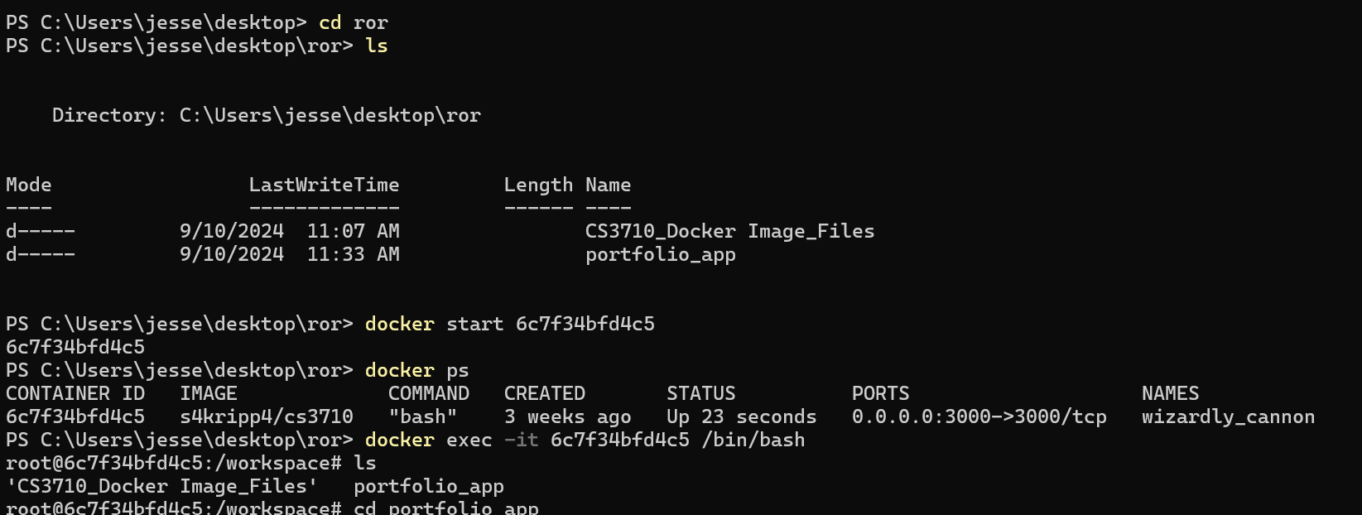

Screenshot shows command prompts and paths leading from my folder that has RoR projects to the workspace

**Step 3: Create a New Rails Project**

Use Rails commands to create a new Rails project, make sure you followed previous steps and are in the workspace directory.

rails new <project_name>

- this command will generate a new Rails application, the path should look similar to this:

/workspace/<project_name>

mine personally is:

root@6c7f34bfd4c5:/workspace/portfolio_app

**Step 4: Start the Rails Server**

Ensure you are in the correct Rails project directory. Then use command line to start the server.

cd <project name>

or

ls

- to confirm you are where you need to be

rails server -b 0.0.0.0

- starts the Rails web server, the -b 0.0.0.0 part specifies the IP address the server should bind to. This is instructing the Rails server to listen on all available network interfaces, making it accessible from outside the container

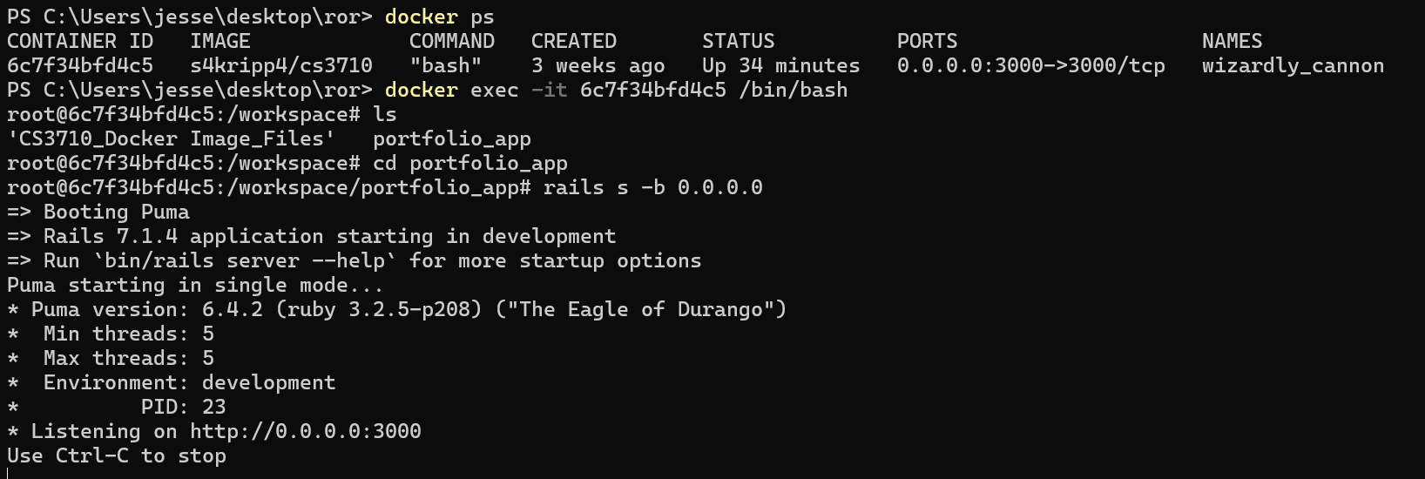

Screenshot shows me ensuring the docker container is running, starting a interactive terminals, CD’ing into workspace/portfolio_app and then starting the server with rails s -b 0.0.0.0

**Step 4: Verify it is working**

Open a web browser and navigate to:

http://localhost:3000/

A Rails welcome page will be there to greet you, indicating your project is running correctly.

Screenshot shows the web browser at http://localhost:3000/, if everything was done correctly. Mine shows work that has already been done inside the workspace through PowerShell

**Step 5: Stopping and Exiting the Rails Server**

Ctrl + C

- stops the Rails server

exit

- typing exit in the #workspace will exit the Docker container workspace